Champlain College - Lennoxville
Final game project: prototype
PROGRAM: | 420.B0 Computer Science Technology
COURSE: | Game Programming 1
COURSE CODE: | 420-440-LE
WEIGHT: | 5% of the final score
SEMESTER: | Winter 2025
INSTRUCTOR: | Francis Gauthier  fgauthier@crcmail.net | Office C-308

Final project breakdown
Aspect | % of the final grade
Prototype and game design document – (team grade) – April 7th to 25th | 5%
Scrum participation and follow-up (individual grade) – April 22nd to May 15th | 5%
Implementation (individual grade) – April 25th to May 15th | 15%
Oral presentation (individual grade) – May 13th and 15th | 5%
Total | 30%

Part 1 - Analysis (50%)

Game Design Document (GDD)
You will have to fill out a game design document (GDD). Your GDD will be a reference when it comes to the decisions you will make throughout the project. By having a clear vision, you will hesitate less when programming your video game and assessing your priorities.
Provided:
- A template document to be filled out.
To do: Fill out the GDD template provided with your teammates. You can answer with phrases or bullet point information.
* Some constraints are present in the GDD template, so you will have to adapt your game to those.

Trello board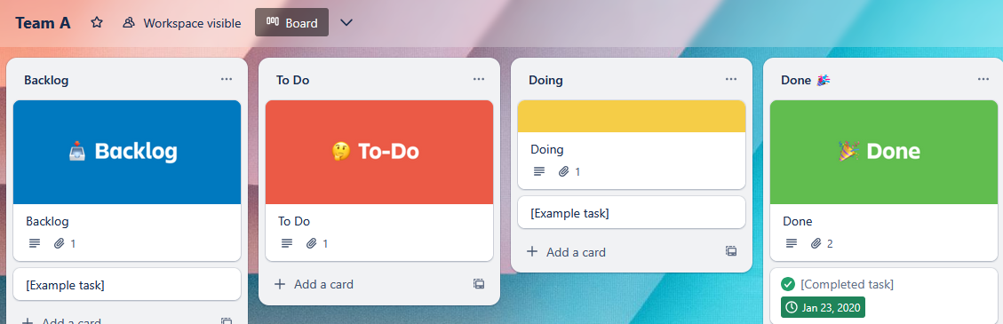
You will be provided with a Trello board for your team. In it, you can track the progress of the many tasks to complete for your game.
You will receive a link to access your Trello Board. (You might have to create a Trello account). In your board, you should:
- Create around 12 tasks* than you plan on doing in your project.
- For each task:
  - Add a name
  - Add a small description
  - Place it in the To Do column
  - Prioritize it. The top tasks are highest priority, down the list are lower priority.
*Tasks are called cards in Trello

Part 2 - Game prototype (50%)
You must start building your game next. The next task is to prepare a prototype that will be the starting point of the main implementation.
The game prototype must include:
- A main menu scene with a Play, Options and Exit
- A gameplay scene, which must provide enough to understand:
  - Game genre
  - Theme & art style
  - Who is the main character
  - How do we control the main character
- Things that should be left out of the prototype:
  - Any time-consuming or complex feature
  - Special effects
  - Scoring, save data

Assets & external scripts
Your prototype can contain external material, like sprites, animations, audio & scripts. The assets must be publicly available and free. For every external asset used, you must mention in a Readme.md file:
- Mention the author
- Mention the assets/library name
- Provide a link to the Unity asset store

Submission
- The game design document must be submitted through LEA. One per team is sufficient.
- Your Trello project must contain your tasks. I will always have access at your Trello board, so simply make sure that it is correctly updated on the submission deadline.
- The game prototype must be set up in a git repository. You must have:
- A private git repository for hosting your game code
- Members on the repository: the 3/4 team members and your teacher (frangauthier username on GitHub)

Submission deadline is Thursday April 24th 2024, End of day.
Late submission will be heavily penalized (-50%).

Evaluation

Appendix 1

Marking rubric - Analysis - Game design document & tasks descriptions

Perfect (100%)
Each section of the GDD is filled out.
The document has been filled out thoroughly.
Sections provides sufficient information to understand the main idea of the game.
The story, characters and the theme fit well together.
The game is complex enough, without seeming unrealistic or too difficult to implement in the time given.
The project tasks are entered in the Trello board
The project progress is split into 12 tasks or more
The tasks are well defined and the task are well prioritized

Excellent (90%)
Each section of the GDD is filled out.
The document has been filled out consciously.
Sections provides sufficient information to understand the main idea of the game.
The story, characters and the theme fit well together.
The game is a bit too complex or too simple to implement in the time given.
The project tasks are entered in the Trello board
The project progress is split into 10 tasks or more
The tasks are well defined and the task are prioritized

Great (80%)
Most section of the GDD are filled out.
Sections provides sufficient information to understand the main idea of the game.
The story, characters and the theme somewhat fit together.
The game is a bit too complex or too simple to implement in the time given.
The project tasks are entered in the Trello board
The project progress is split into 8 tasks or more
The tasks are defined, and the task are prioritized with only few mistakes

Acceptable (60-70%)
Most section of the GDD are filled out.
The document has been filled out briefly.
Sections provides sufficient information to understand the main idea of the game.
The story, characters and the theme are poorly described.
The game is a bit too complex or too simple to implement in the time given.
The project tasks are entered in the Trello board
The project progress is split into 6 tasks or more
The tasks names are defined, and the task are somewhat prioritized

Poor (less than 60%)
Few sections of the GDD are filled out.
The document has been filled out briefly.
Sections provides little information to understand the main idea of the game.
The story, characters and the theme does not fit well together.
The game too complex or too simple to implement in the time given.
The project tasks are not in the Trello board
The tasks number and prioritization are insufficient.

Marking rubric - Game prototype

Perfect (100%)
All of:
- The game prototype is available through source control
- A built version of the prototype is also available through source control
- The game contains a main menu with a Play, Options and Exit button
- The game main scene allows to control a character or play the game as intended by the game genre
- The main scene provides information on the game theme and art style

Excellent (90%)
Most of:
- The game prototype is available through source control
- A built version of the prototype is also available through source control
- The game contains a main menu with a Play, Options and Exit button
- The game main scene allows to control a character or play the game as intended by the game genre
- The main scene provides information on the game theme and art style

Great (80%)
Most of:
- The game prototype is available through source control
- A built version of the prototype is also available through source control
- The game contains a main menu with a Play, Options and Exit button
- The game main scene allows to control a character or play the game as intended by the game genre
- The main scene provides information on the game theme and art style
- Some external assets are used, but no mention of it can be found in a Readme.md

Acceptable (60-70%)
Few of:
- The game prototype is available through source control
- A built version of the prototype is also available through source control
- The game contains a main menu with a Play, Options and Exit button
- The game main scene allows to control a character or play the game as intended by the game genre
- The main scene provides information on the game theme and art style
- Some external assets are used, but no mention of it can be found in a Readme.md

Poor (less than 60%)
The prototype shows little information on the game direction.
The prototype is not playable or built correctly because it contains script errors.
The prototype does not allow to assess the goal game, theme or characters in play

